Lab1

8- Create virtualhost for os.iti.gov.eg website

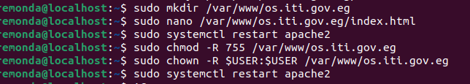

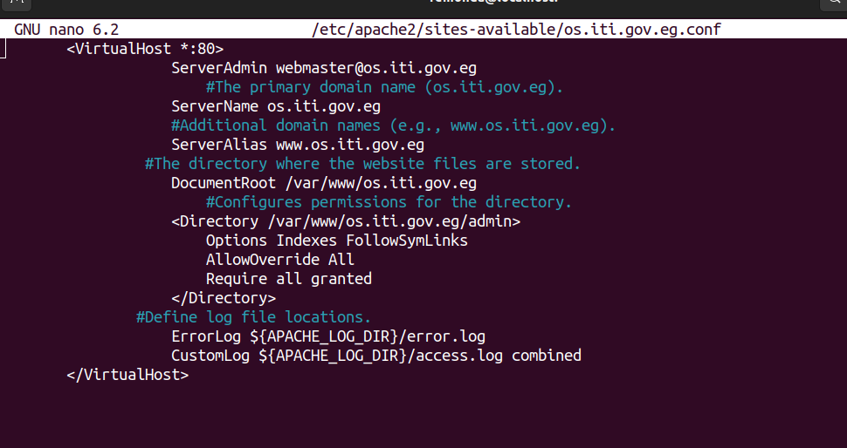
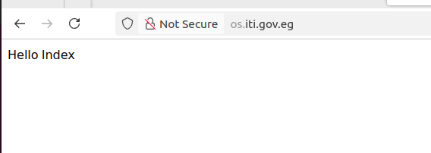

9- Enable rewrite module

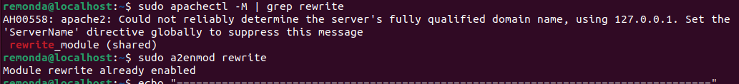

10. What is the importance of rewrite module?

1- Clean URLS

dynamic URLS is complex RewriteRule convert to frinendly formats

2- Redirection (301/302 Redirects)

redircts old URLS to new or other (e.g., old.com → new.com).

3- Preventing Hotlinking (forbidden)
مثلا موقع بيسمح بستخدام صورك الحل منع عرض الصورة

4- Security Enhancements

Hides sensitive file paths و Blocks malicious requests

5- Dynamic Routing in Web Apps

Ensures only one version of a URL is accessible
(e.g., example.com vs. www.example.com)

6 - Canonical URLs

Frameworks (like Laravel, WordPress) use rewrite rules to map URLs to backend scripts (e.g., /profile → index.php?page=profile).

lab2

1- Configure apache to use Worker MPM

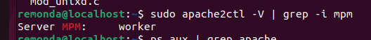
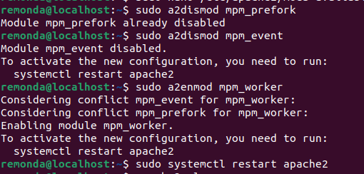

2- Check the status of rewrite_mod and enable it if it is enabled

3- Write RewriteCond and RewiteRules for:

a- Deny access to http://localhost/page?queryString if queryString contains
the string forbidden.

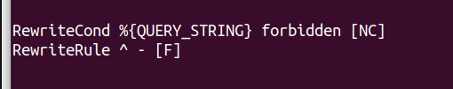

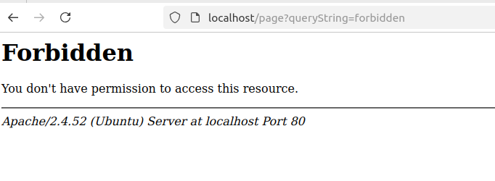

b- Remove the Query String



c- Rewrite URLs like http://localhost/page1?var=val to
http://localhost/page2?var=val but do not rewrite if val isn't present.

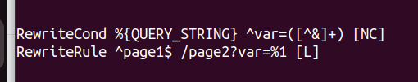

d- Take a URL of the form http://localhost/path?var=val and transform it int

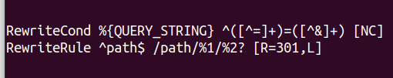

e- Map http://localhost/example/one/two to

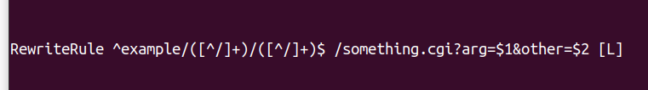

f- (Bonus) Display a goodevening.html page if the time is after 6:00 PM and
goodmooring.html page if the time is before that

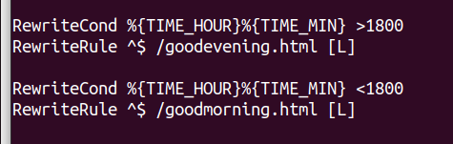

4- Create a virtual host for os.iti.gov.eg to redirect to a local directory in your server.

